
COMSATS University Islamabad
( Vehari Campus)

Subject: Exploring Quantitative Skills Class: FA24-BEN

QUIZ NO:1
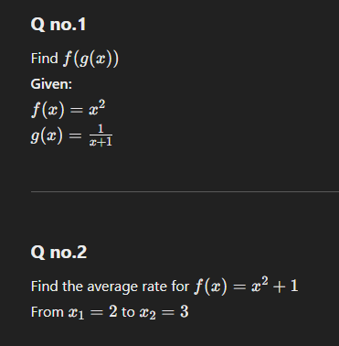

QUIZ NO:2
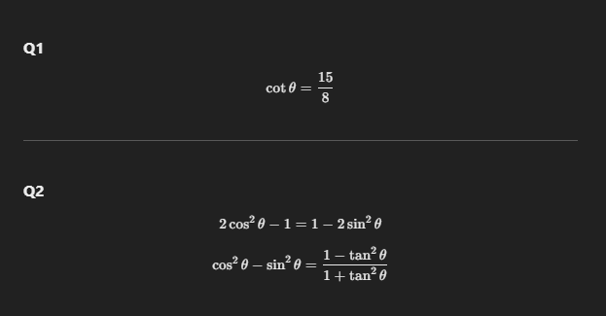

ASSIGNMENT NO:1
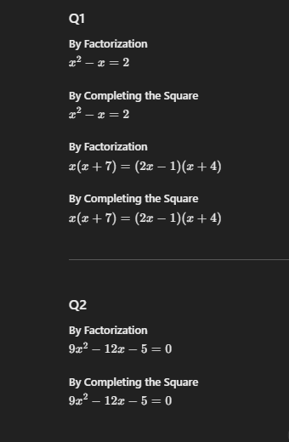

ASSIGNMENT NO:2
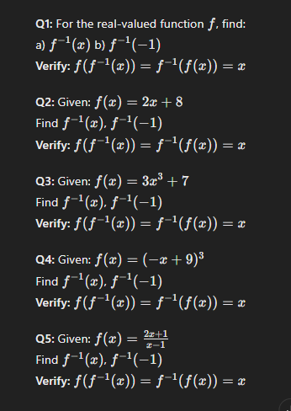

QUIZ NO:3
Q:1:
Find the annual percentage yield for any investment that earns 8% per year compound.
Q:2:
- Define Devise a plan.
- Review the Solution.

ASSIGNMENT NO:3
Introduction and Deductive Reasoning:
Q:1:
3 , 5 , 9 , 15 , 23 , 33,..?

Q:2:
3/5 , 5/7 , 7/9 , 9/11 , 11/13 , 13/5…?

Q:3:
2 , 7 ,-3 , 2 , -8 , -3 , -13 , -8 , -18…?

